**AWS Task-2**

**Task Description:**

*Set up a VPC with an Internet gateway, create a public subnet with 256 IP addresses, a private subnet with 256 IP addresses, make a route table connecting the Internet gateway and the subnets, and launch a Linux EC2 instance by using the above VPC and public subnet.*

Steps:

1. Set up a VPC

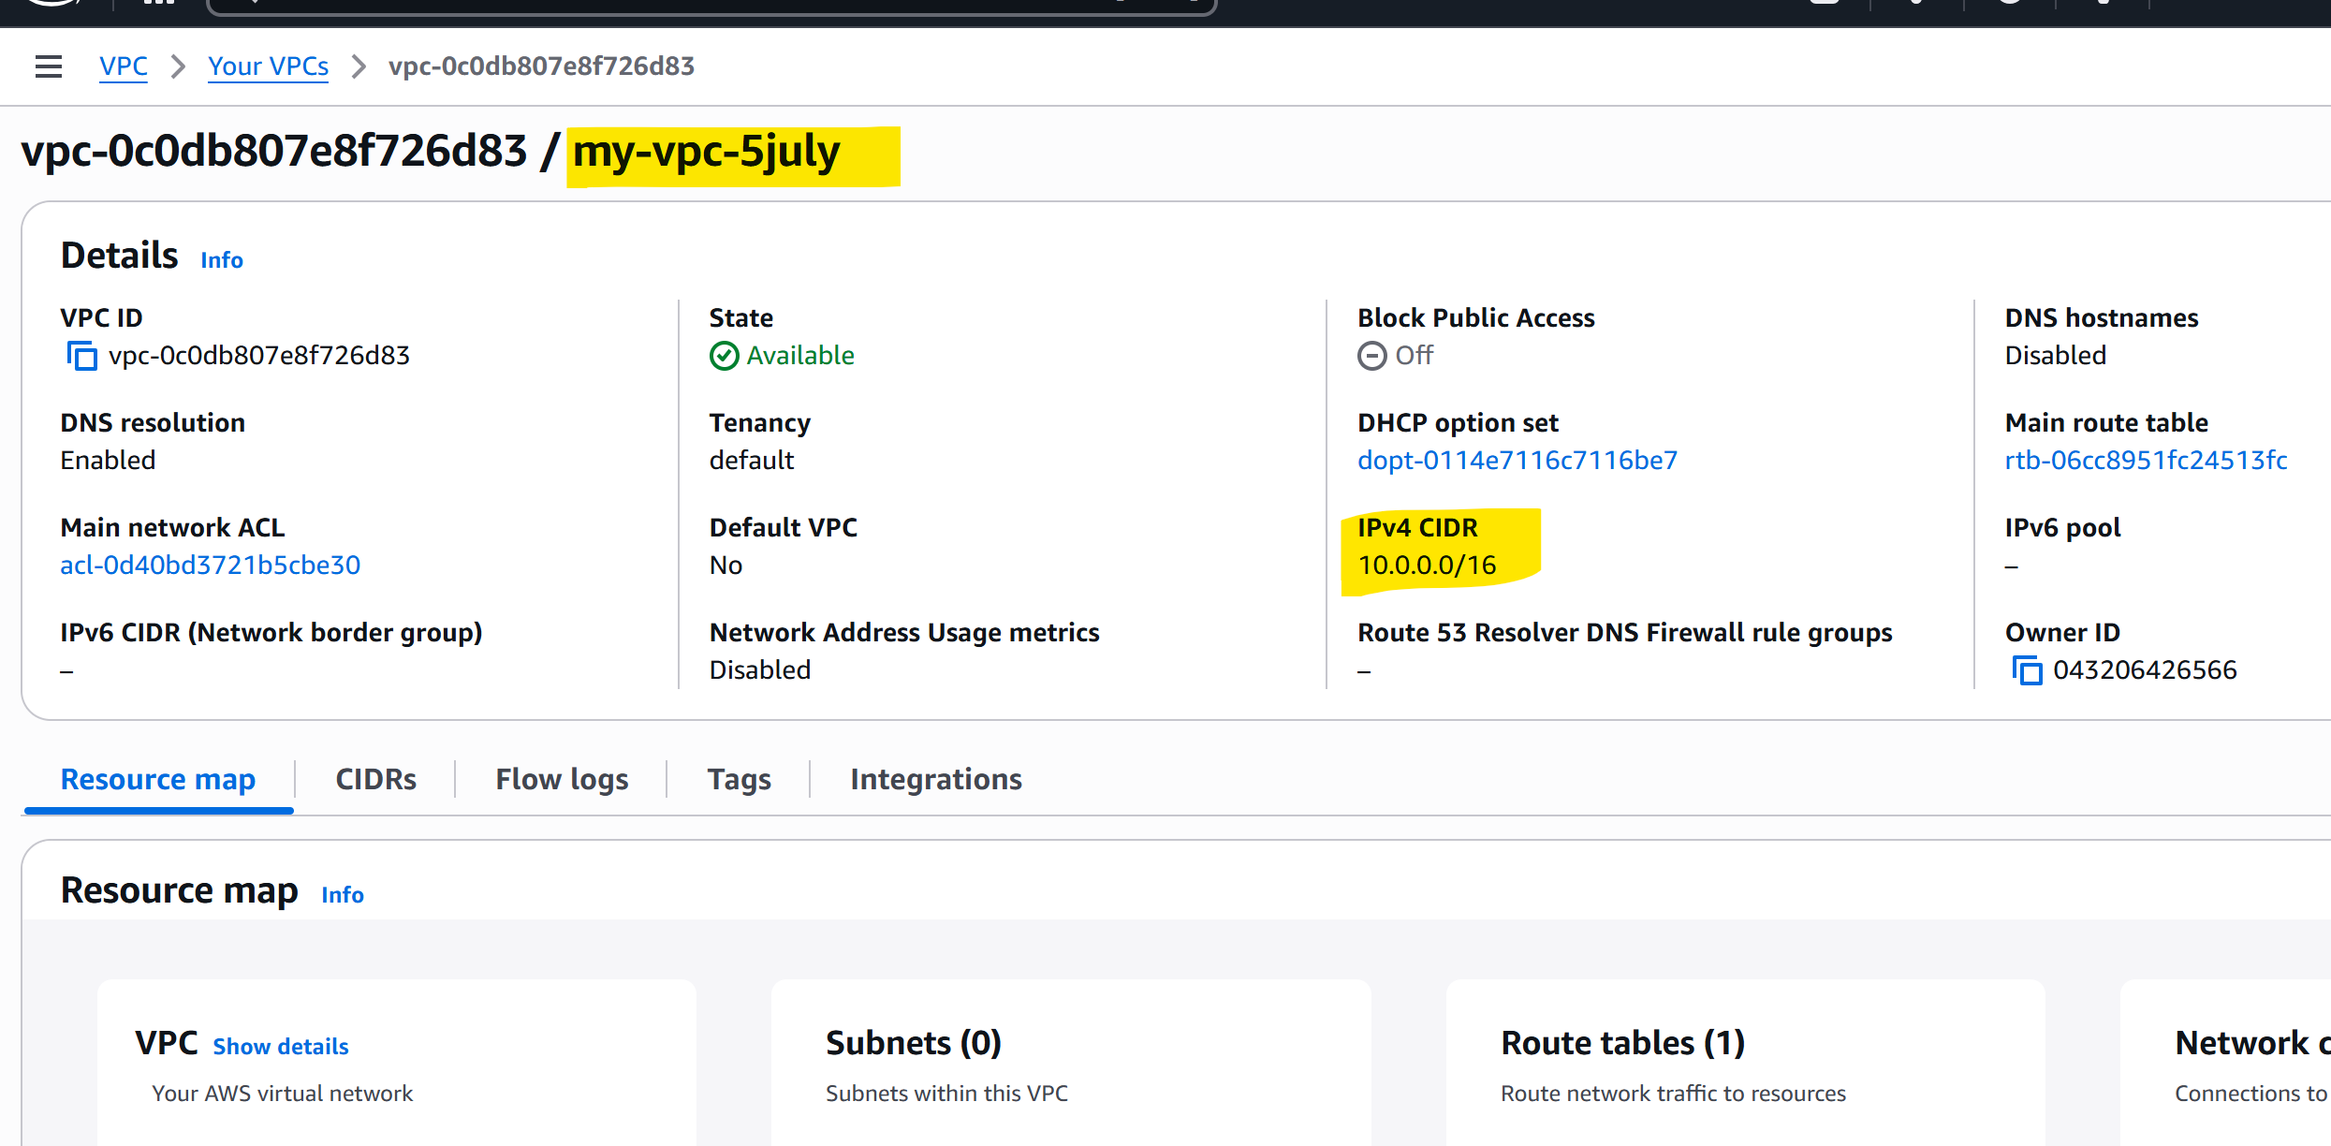

1. Created Internet gateway and mapped VPC to it

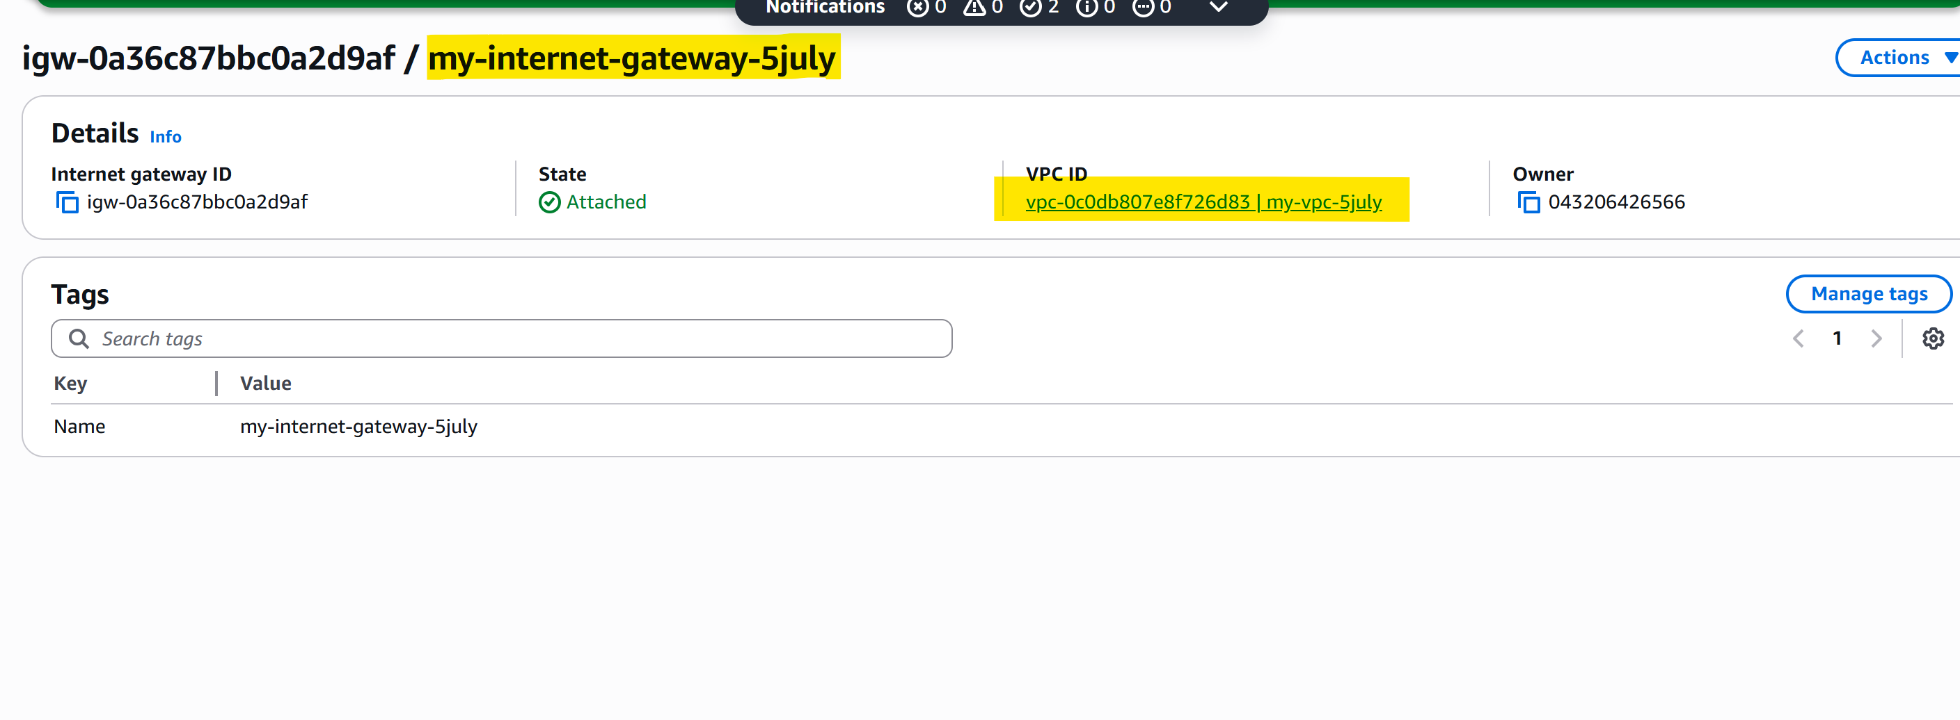

1. Created 2 subnets

* public subnet with 256 IP addresses and a private subnet with 256 IP addresses
* reserved some IP address so started it from 10.0.1.0/24

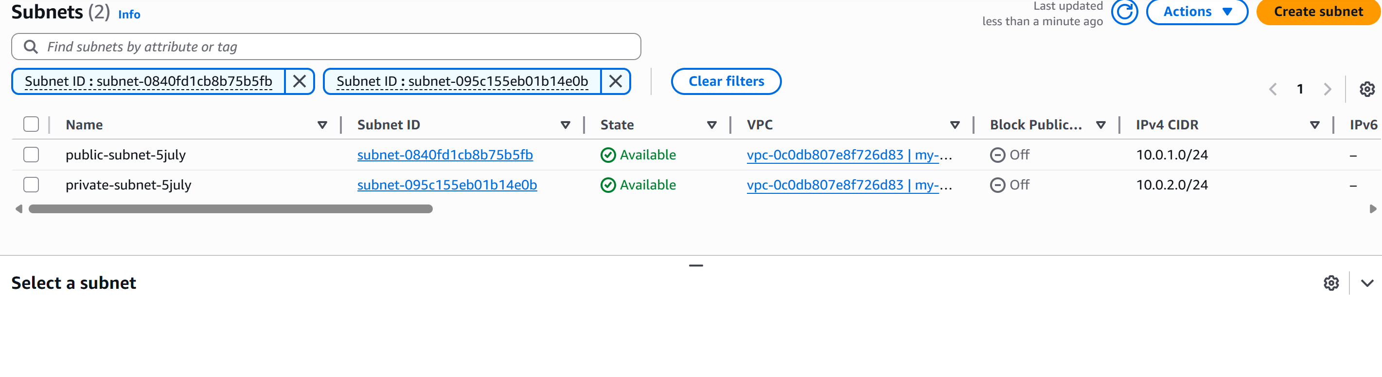

1. Create Route table

Map the VPC and in route add the internet gateway

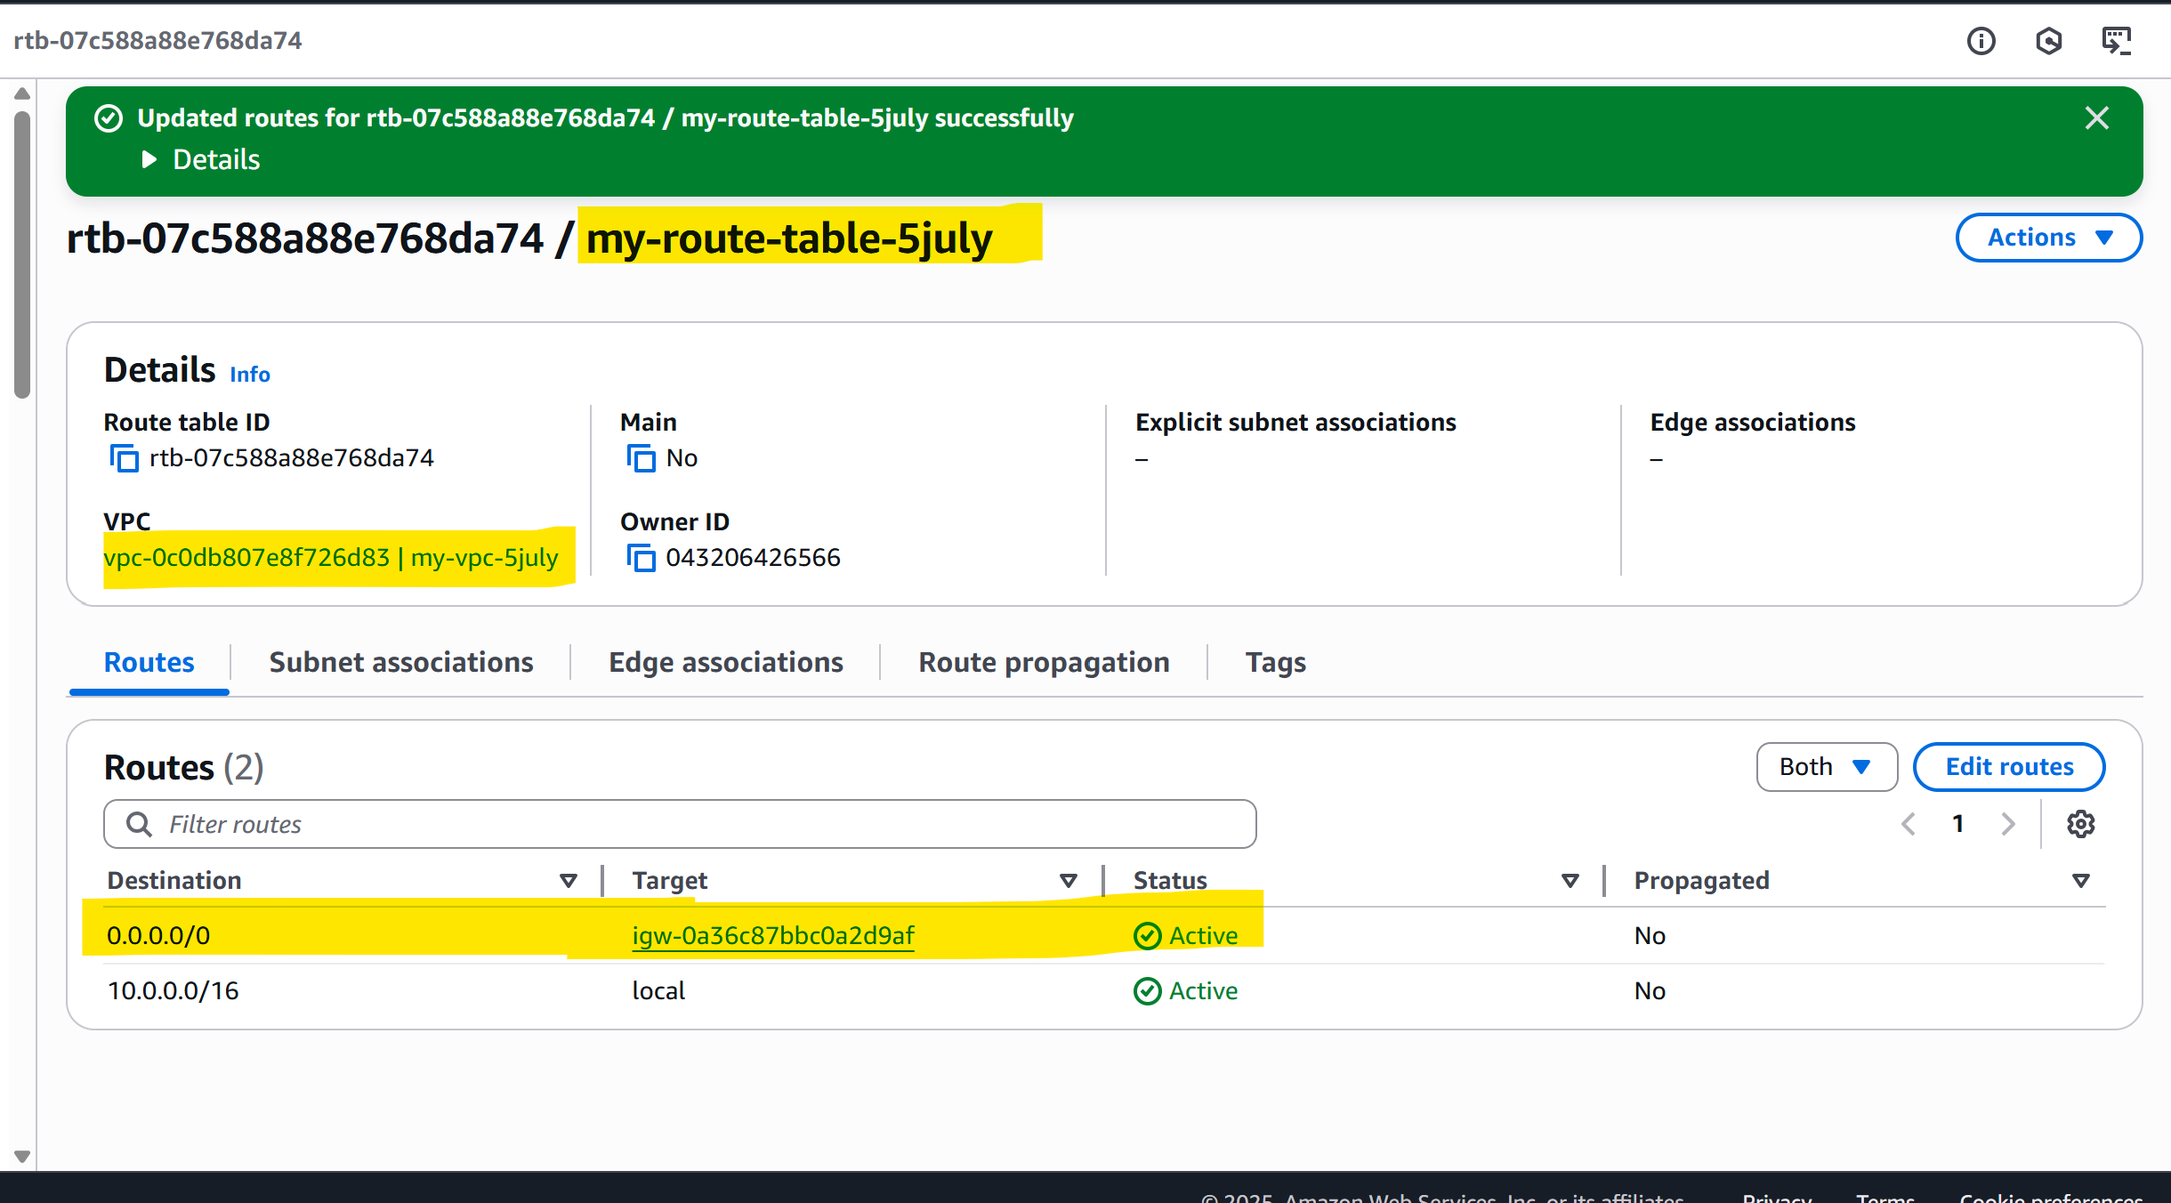

1. Associate the public subnet to the newly created route table

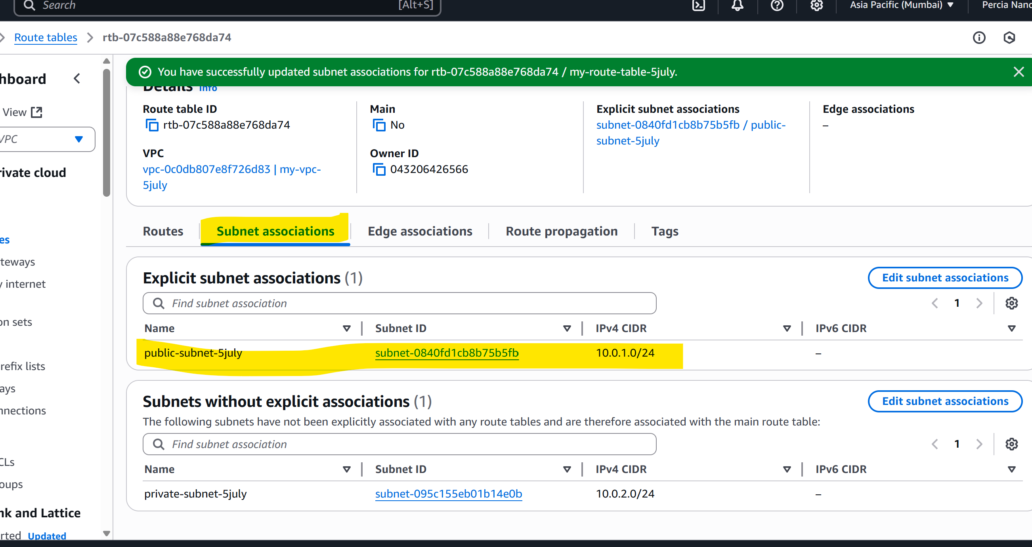

1. Launch Instance

* Mapped the newly created VPC and public subnets
* In security group, allowed HTTP

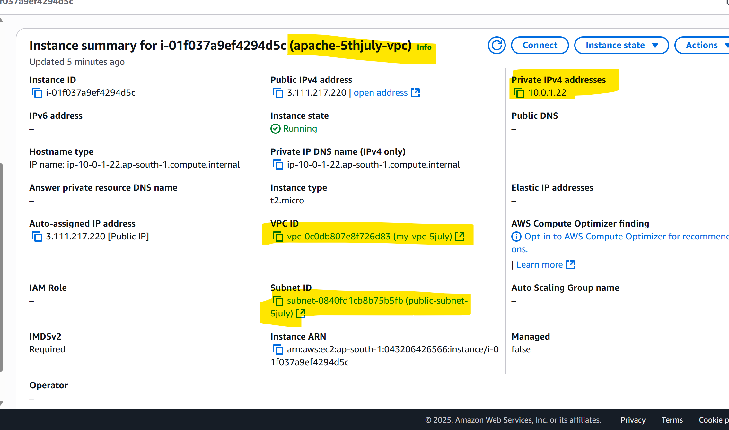

*private IP is from public subnet,*

* *launched EC2 instance into the public subnet (10.0.1.0/24)*
* *AWS automatically assigned it a private IP from that subnet —10.0.1.22*

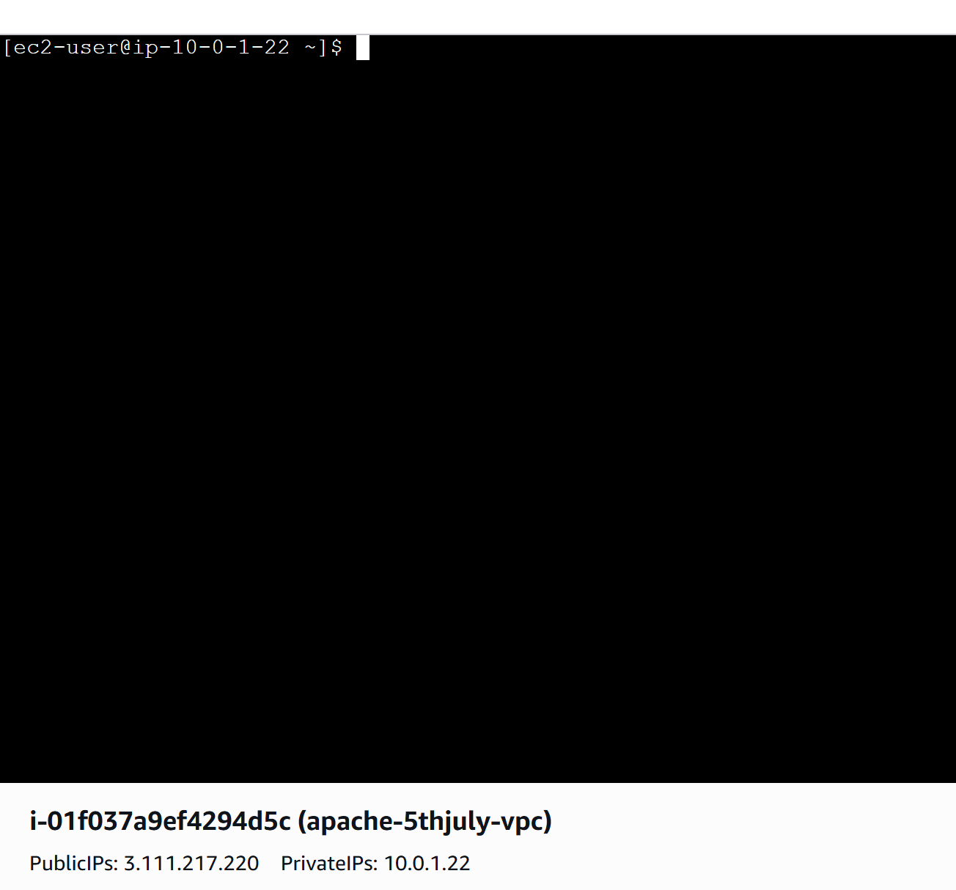

Able to access public IP in browser

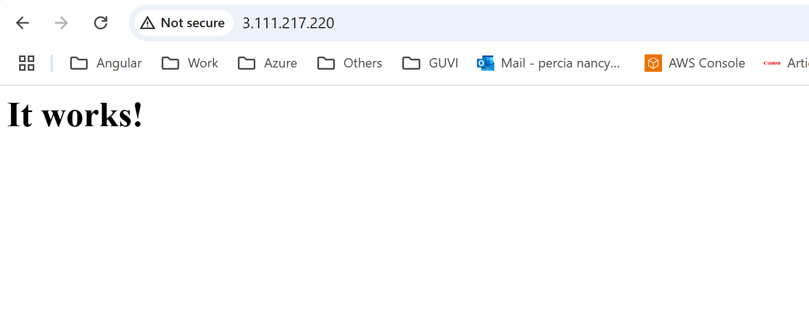

Able to access Private IP inside instance

